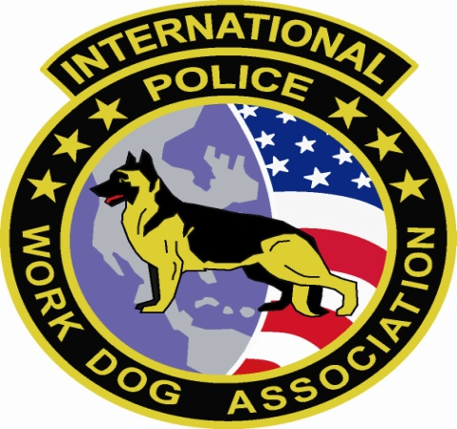501(c) 3 Non-Profit Organization Federal Tax Identification Number # 20 5883593
Send donation to:
IPWDA Treasurer
131 Gurney Lane
Raeford , NC 28376

Corporate/Friends Sponsors
With the support of sponsors, the IPWDA Training and certifications can succeed.
Leave your unique mark on the IPWDA with a corporate sponsorship today!
If your company is interested in sponsoring the IPWDA, please contact: ipwda1@yahoo.com

Platinum - $10,000
Booth space at the National Conference of the International Police Work Dog Associations function
Banner recognition at all International Police Work Dog Associations functions
Invitation to all functions
Website Recognition
“Top K-9 Kop” Award Recognition

Gold - $5,000
Booth space at International Police Work Dog Associations functions
Banner recognition at all International Police Work Dog Associations functions
Invitation to National Conference
Website Recognition
Member Recognition Plaque

Silver - $2,500
Booth space at all International Police Work Dog Associations functions
Banner recognition at (sponsor’s choice) International Police Work Dog Associations function
Website Recognition
Member Recognition Plaque

Bronze - $1,500
Booth space at all International Police Work Dog Associations functions
Website Recognition
Association Sponsor Certificate

Friends- $500
Website Recognition
Association Certificate of Appreciation

